Rajender kethipalli hw 1

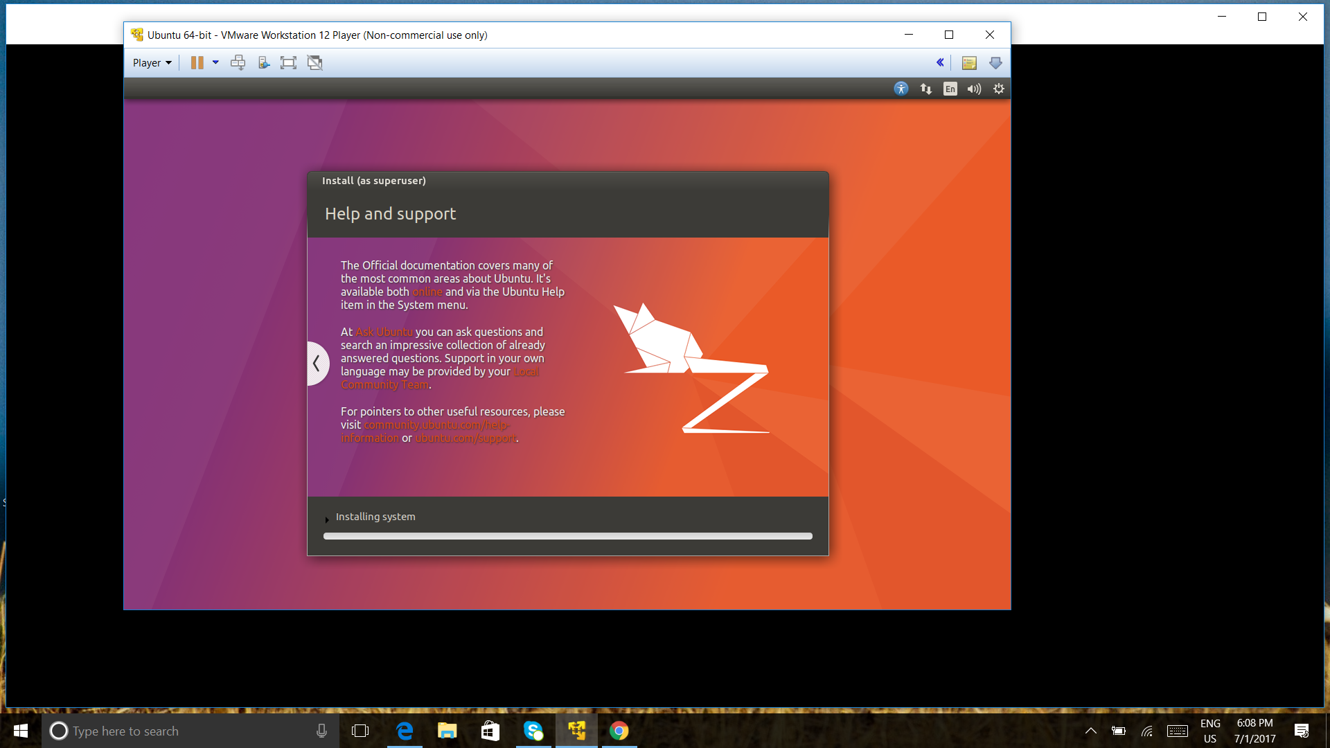

INSTALLATION OF LINUX BSD

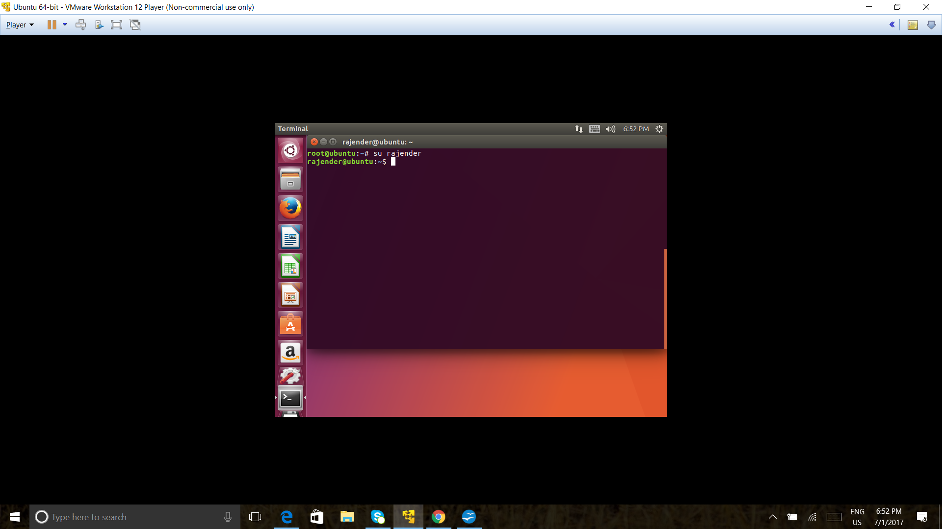

CHANGING ROOT TO THE SUPER USER

SUDO BASH

SU RAJENDER

PWD AUTHENTIACTION

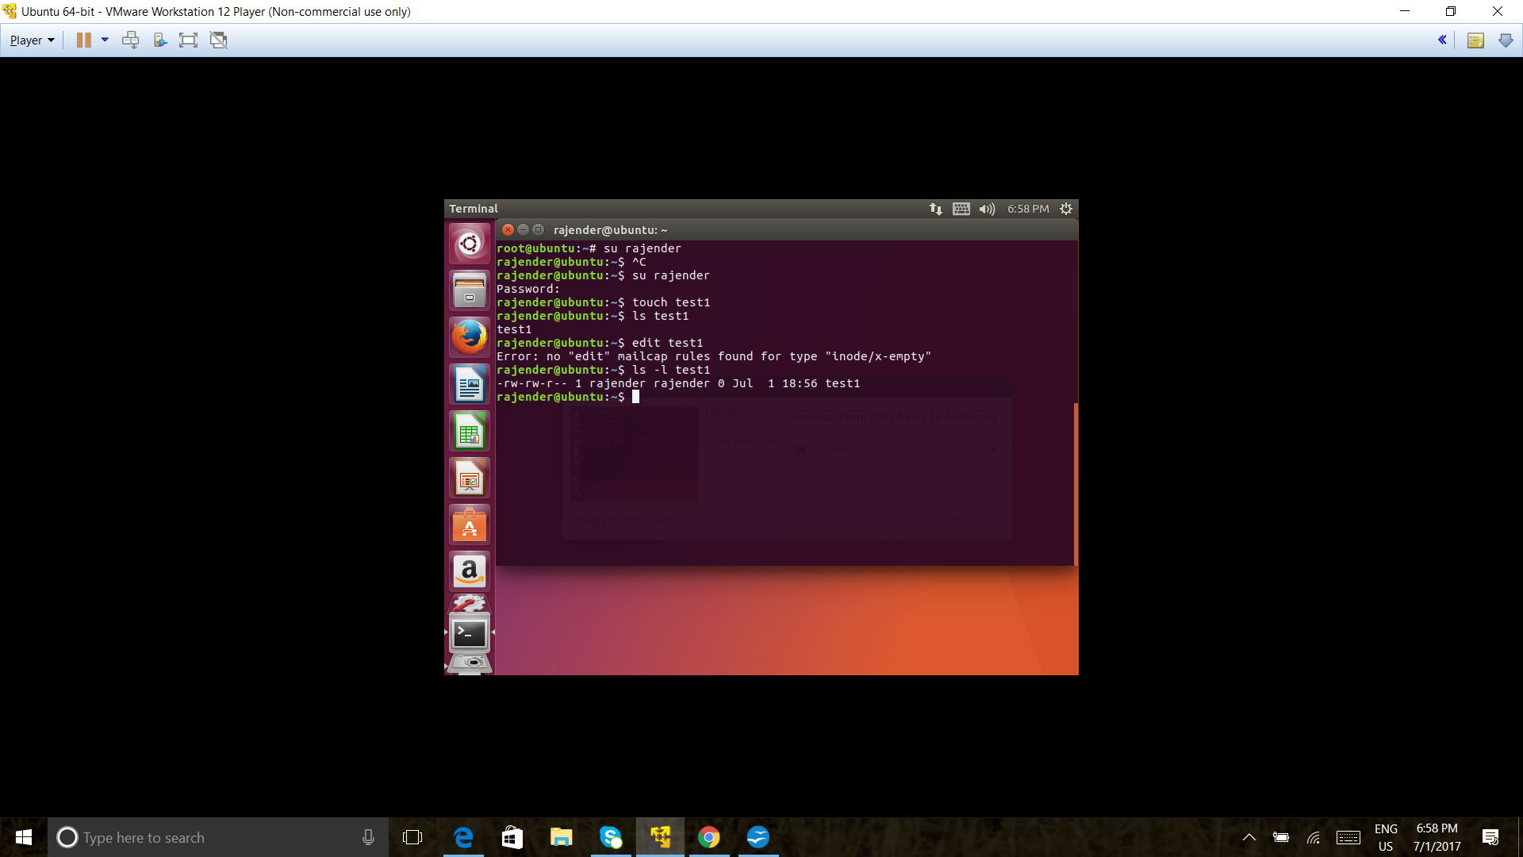

CREATING FILE USING TOUCH

TOUCH TEST1

LS -L TEST1

DISPLAYS FILE ACCESS CODES

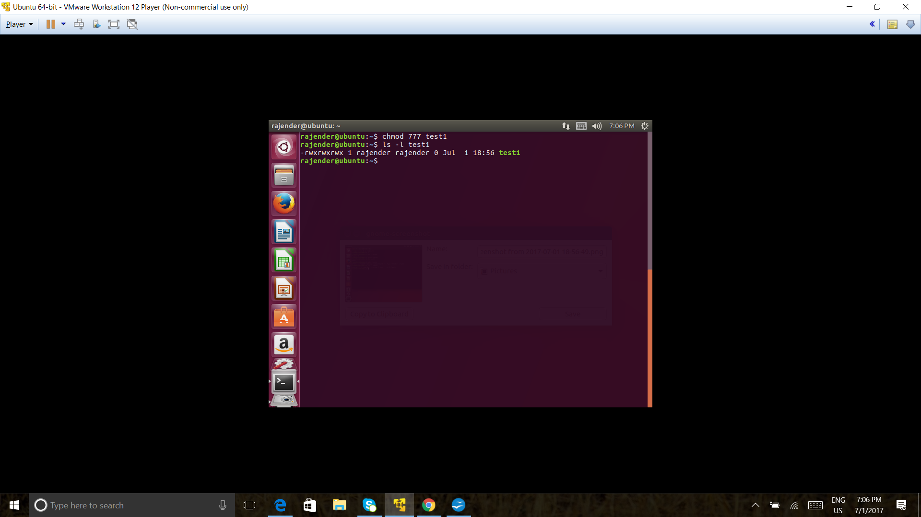

CHMOD 777 TEST1

